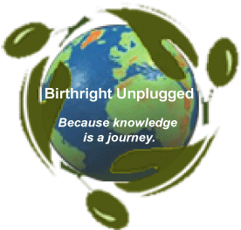

Sample Fundraising Letter for Birthright Unplugged Trip

Dear friends and family,

I'm writing to tell you about a journey I am about to take, and to ask for your support in doing so.

This summer/winter, I will be traveling to the West Bank with Birthright Unplugged (www.birthrightunplugged.org), an organization that provides opportunities for mostly Jewish North American people to meet with Palestinian people and learn about daily life under occupation. This trip is important to me because… __________________________________________________________________
(you can make it more personal here and add more substance like "many of you know that...." with more information about yourself).

Birthright Unplugged is committed to sharing stories of Palestinian life not only with the participants of the trip, but with a wider circle of people. I share this commitment, and I will ________________________________________________
(write e-mail reports while in Palestine, give a report-back for my community upon return, etc.).

The cost of the six day Birthright Unplugged trip is $350. I will also be purchasing a plane ticket for $1,000. The other costs of my trip will be $____ (depending on how long you're staying, etc.). I can personally put in $____ towards the cost of my trip, and would like to raise the other $____ from supportive friends and family. Please let me know if you are able to donate, and how much. You can send all donations to (add your address here).

Thank you for reading, for your interest in my life, and for your support as I work for peace and justice in Israel/Palestine.

Sincerely,

(your name)

